Press release, 24. 9. 2024: Antonio Pichillá, *The Offering*, MGLC Švicarija, 18. 9. 2024–12. 1. 2025.

**Antonio Pichillá, The Offering   
18. 9. 2024–12. 1. 2025**

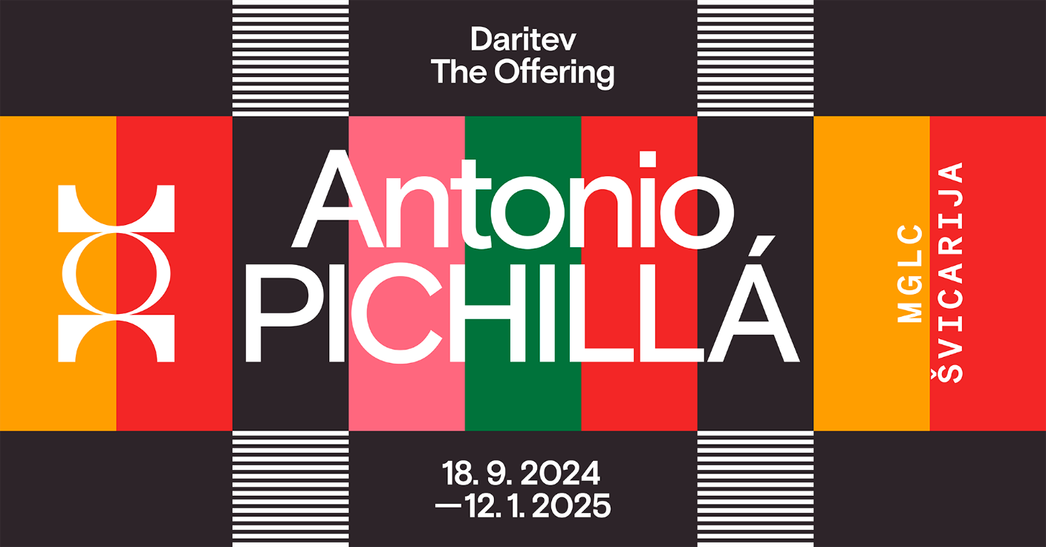

Antonio Pichillá Quiacaín (born in 1982 in San Pedro La Laguna, Sololá) belongs to the Maya Tz'utujil ethnic group. He is part of a new generation of Guatemalan artists who, with the help of strategies acquired through formal education, are redirecting the Eurocentric perception of Maya art and disclosing the contemporary significance of the wisdom of their ancestors. In his work, he transcends boundaries and explores new connections beyond the conventional framework of contemporary art as an artist, healer, cultural mediator and respected member of the community.

Through his art practice, Pichillá analyses and reinterprets his cultural heritage, thus transforming artistic creation into a ritual act that can honour his ancestors and give continuity to inherited knowledge. His works, shown in the exhibition The Offering, were created by Lake Atitlán, which is considered the geographical area of the country where Maya culture is most deeply rooted. They are based on Maya myths, legends, rituals and iconography, respectfully preserving ancestral wisdom while creating new narratives that build on the Maya cosmogony. This worldview, based on the harmony between nature, the universe and humanity, remains a fundamental element of the culture of indigenous communities in Guatemala today.

The guiding thread of the exhibition The Offering is the art of weaving, demonstrating that spirituality is an inherent part of artistic materiality. In the Maya language, there is no specific word for art; instead, they use the term "x’ajaan", which means sacred. Through appropriation, performativity and abstraction, the artist connects Maya rituals and customs that have long remained hidden, disclosing the value of ancestral knowledge as a symbol of resistance and the dignity of one's identity.

Curator: Yasmín Martín Vodopivec

-----------------------------------------------------------------------------------------------------------------------

Contact for press: Sanja Kejžar Kladnik, sanja.kejzar@mglc-lj.si, 041 373 916

-----------------------------------------------------------------------------------------------------------------------

Supported by:

