Exhibition Marko Šajn, Mutual Compromise on view at the International Centre of Graphic Arts in Ljubljana from 10. 3. till 16. 4. 2023 (Tivoli Mansion in Tivoli Park).

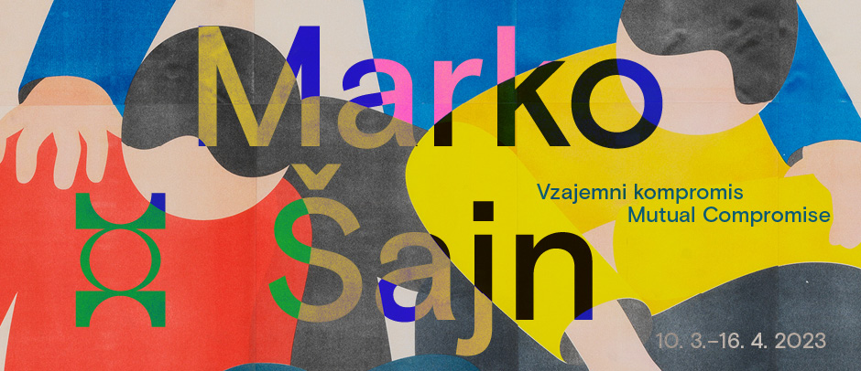

Marko Šajn, Mutual Compromise
10. 3.–16. 4. 2023

Opening of the exhibition on Friday, 10 March 2023, at 1 pm, at the International Centre of Graphic Arts in Ljubljana (Pod turnom 3, Ljubljana, Slovenia).

Marko Šajn's prints are characterised by a clear concept and perfect execution, a humorous, funny, fast-paced, witty and playful artistic expression with many references to art history, classical painting, popular printmaking, urban culture, graffiti and street art. He focuses on the motifs of human bodies that form diverse pictorial compositions through movements and different positions. We can observe handshakes, hugs, pushing and shoving, tripping, gestures of help, tiredness of bodies, surprises, marching, provocation, balancing and much more, which can be represented by human figures without facial expressions and gestures, but rhythmically and harmoniously.

The interweaving of the figures is complemented by carefully selected combinations of coloured surface areas. The primary colours red, yellow and blue, together with the connecting black, form various colour combinations and effects in a largely vacant and indeterminate space against an infinite background. The lightweight figures are like movable toys with which he forms elaborate compositions that captivate the viewer's gaze. The human body, as understood and depicted by Marko Šajn, is a treasure trove of visual language, body language and many situations that humans can only convey through their bodies, gestures, movements and positions. The compositions of the bodies seem like minimalistically conceived and skilfully executed choreographies of a well-thought-out theatre or dance performance, in which each figure has a precise place, position, role and expressive quality. His prints, paintings and drawings can be compared to theatre photography and the significance of photography in contemporary dance. Despite their illustrative and narrative directness, they are full of hidden inclinations and speculations. Šajn has brought his figure to the value of a sign, which is a peculiarity of the art production by a generation that associates its work with graphic design, visual communication, music making and other forms of urban art. He depicts bodies and does not care about belonging, gender or race. They are seen and understood as human bodies, but could just as easily be dolls, puppets, silhouettes, graphic signs or typefaces. Their colourfulness lies in their uniformity and simplicity, with no sign of gender identity or religious affiliation; they are like faceless bodies and synonymous with the present day. There is no excessive variation between the bodies themselves, only colour differences. The uniformity of the figures is a kind of physical compromise that Šajn uses to tell a story about space and the relationships between bodies. In fact, Šajn minimises the human figure to the point where it is not seen in the context of material human presence, but rather in the context of communication, virtual reality, the mastery of space, the environment and the relationships that constitute human beings. Subject and object at the same time.

Šajn explores the possibilities of using physical movement to create distinctive pictorial forms, meanings and relationships, and the silkscreen technique suits him well, as its technical properties visually reinforce the motif, the content and the conception of the play between forms and colours. His riso collages are a speciality. These are large-format prints composed of many smaller A3 prints. They show the technical unpredictability of riso printing, the shifts and uneven colour contrasts that ultimately give the works a special pictorial quality. Riso printing is a relatively demanding printing technique where the printmaker has to find the right balance between his idea and the possibility of its realisation and the technical peculiarities of the riso printer. The printing process and the size of the prints enable him to assemble the prints and thus the special grid structure of the finished works.

The distinctive feature of the exhibited works is the object, the sculpture, the foldable body of steel, the metallic cube of forms that emphasises the flatness of the colours and the playfulness of the physical connections, which is why it is malleable and fragile in some places, bends and appears unstable, and combines into a solid mass in others. With this object, Šajn's figures, although trapped in a three-dimensional loop, have descended into real space for the first time.

In the context of contemporary print production, Marko Šajn stands out for his simple but refined and thoughtful visual expression, in which he skilfully incorporates the technical features of individual printmaking techniques, procedural peculiarities and unpredictable printing errors. His prints are characterised by a bold choice of colours and the skilful integration of figurative interweaving of colour surface areas, between which he leaves enough space for the viewer's imagination.

Božidar Zrinski, curator of the exhibition

Marko Šajn (1990) studied Painting and Printmaking at the Academy of Fine Arts and Design in Ljubljana. He works as a visual artist and graphic designer. He is an active member of the Hiša kulture gallery in Pivka and the Ljubljana-based art collective Riso Paradiso. His first solo exhibition The Grave Is the Door to Your Rebirth was held in Tovarna Rog in 2015, followed by Lost in Space at Hiša kulture in Pivka and Wide Awake at DobraVaga, Ljubljana. Since 2015, he has regularly exhibited in solo and group shows. Last year, his work was included in the survey exhibition of recent Slovenian printmaking Prints and Impressions 2 at the International Centre of Graphic Arts. Since 2009, he has published many photographic and drawing zines, including Lost in Space (2019) and in 2020, as co-author, the drawing book Riso Paradiso 33 1/3. He lives and works in Pivka.

-------------------------------------------------------------------------------------------------------------------------

ACCOMPANYING PROGRAMME

-------------------------------------------------------------------------------------------------------------------------

Honza Zamojski
Middleman
10. 3.–28. 5. 2023, MGLC Tivoli Mansion

In Honza Zamojski's latest exhibition, the eponymous Middleman plays various roles. He is a viewer who, upon entering the exhibition space, stands in the middle of the symmetrical architecture. He is also an author who mediates between the world of ideas and the material world by creating drawings, sculptures and texts. Middleman is also visualised as a simplified and symbolic puppet that can be moved by various forces.

Honza Zamojski's work has been seen in Ljubljana in the main exhibition of the 33rd Ljubljana Biennial of Graphic Arts Crack Up – Crack Down in 2019, as part of which he presented his installation The Gathering and The Meeting at DUM Project Space. He received the Audience Award for his installation.

Exhibition curators: Nevenka Šivavec, Yasmín Martín Vodopivec

-------------------------------------------------------------------------------------------------------------------------

Can it be tried somewhere?
NERO’s Publishing Experimentation
10. 3.–28. 5. 2023, MGLC Tivoli Mansion

NERO is a quarterly magazine and publishing house specialising in artists' books, editions and catalogues that respond to the spontaneous need to connect to a broader cultural discourse and use art to explore the imaginaries of the world to come and the relevant issues of the present.
It is within this framework and with this aim that the Not (NERO on Theory) series and its webzine were launched in 2018. With its publications that cross and dissolve the boundaries between philosophy, visual arts, science fiction, pop culture, politics and economics, Not introduced to Italy many titles by authors who had already attracted attention within international cultural debate but had not yet been translated. Today, some of these titles are almost indispensable reading for understanding the contemporary world and continue to find great resonance in a wide range of cultural circles.

Middleman, the latest book by Honza Zamojski, which is an illustrative and poetic attempt to describe the Middleman, his everyday life and the reality that surrounds him, will be published by Nero Editions in May.

Concept of the exhibition: Davide Francalanci – NERO

-----------------------------------------------------------------------------------------------------------------------

INFORMATION
Exhibition Mutual Compromise is on view from 10 March 2023 till 16 April 2023. Tuesday to Sunday from 10 am till 6 pm.
Press contact: Sanja Kejžar Kladnik, sanja.kejzar@mglc-lj.si, +386 41 373 916

